Ryan Anderson

11141761

Microscope Lab write-up

April 6/2015

The optical tools available for use were post holders, for holding optical instruments steady on the track; optical posts, held in the post holders and holding the optical components at whatever height was necessary; Irises, for creating field and aperture stops; fixed lens mounts, supported on optical posts and holding lenses in the optical path; a Spanner Wrench, to unscrew the rings in the lens mounts in order to insert or remove lenses; a Variable Diameter optic mount, for holding the light in place; and the slide holder, for holding the materials for magnification in place. Sketches of the materials are provided below.

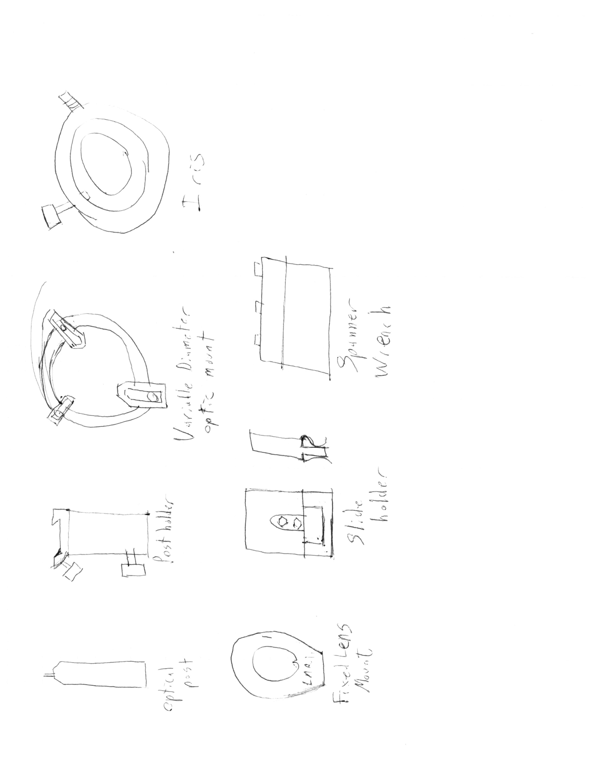

To test the focal length of the lenses, a simple setup was used : setting up the light, then the lens, then the camera. The distance between the light and any lens was fixed, at 36.0 cm, and the goal was to find that point behind the lens where the image was focused as seen by the CCD camera. The general setup was the following:

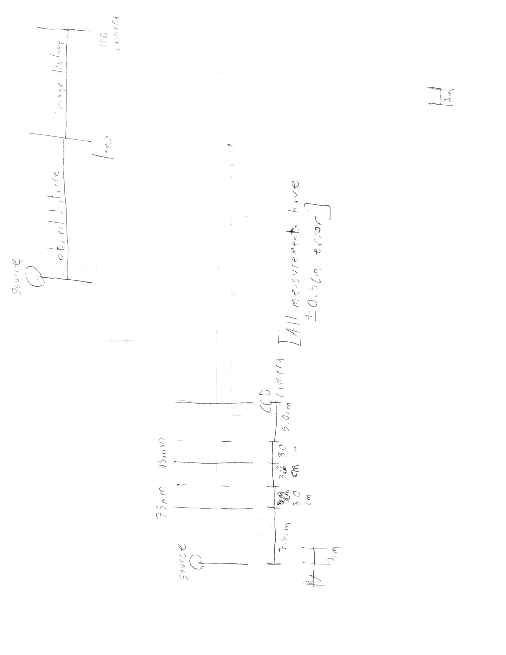

The image desired was of the filament of the lightbulb, which required using it on very low intensity. The point of this procedure is to verify if this formula can verify the focal length of the lens

$$\frac{n^{'}}{l^{'}}=\frac{n}{l}+\frac{n^{'}-n}{f}$$

With the index of refraction of N-BK7 being about 1.5168 for yellow light, the index of air can be assumed one, and with l fixed at 36.0cm, the above formula rearranges for f as follows:

$$f=\frac{n^{'}-n}{\frac{n^{'}}{l^{'}}-\frac{n}{l}}=0.5168/(\frac{1.5168}{l^{'}[cm]}-\frac{1}{36})$$

The images were as follows:

The 40mm focal length image, found 5.5 cm behind the lens:

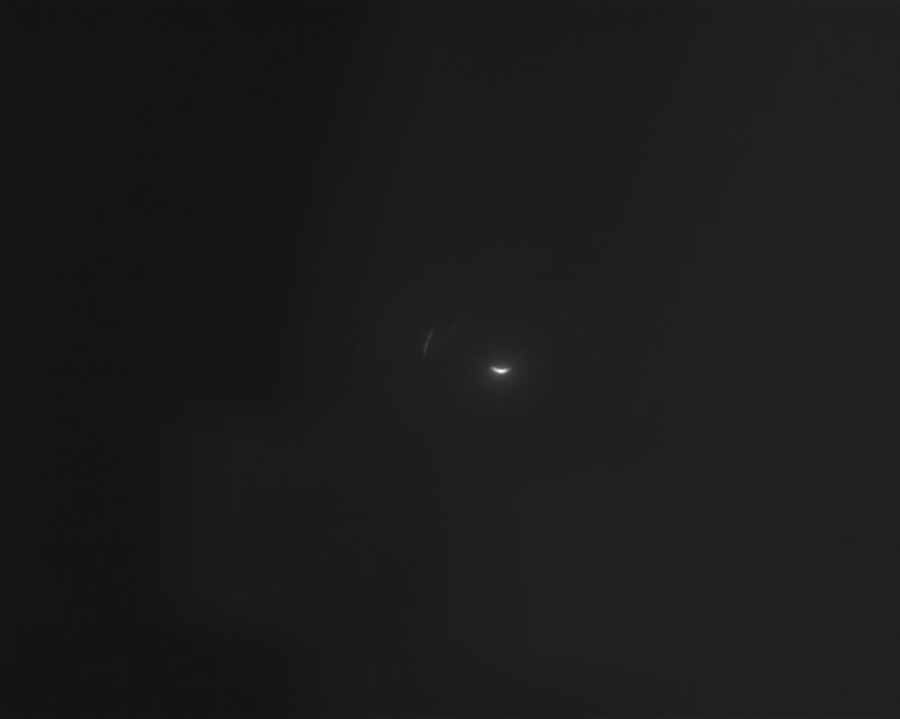

The focal length found using the above formula was 20,8mm, essentially half the required measurement. Curiously, neglecting the 0.5168 factor gave 40.3mm, which is much closer to the used focal length.

The below picture is with the 50mm focal length lens, found 7.0 cm behind the lens:

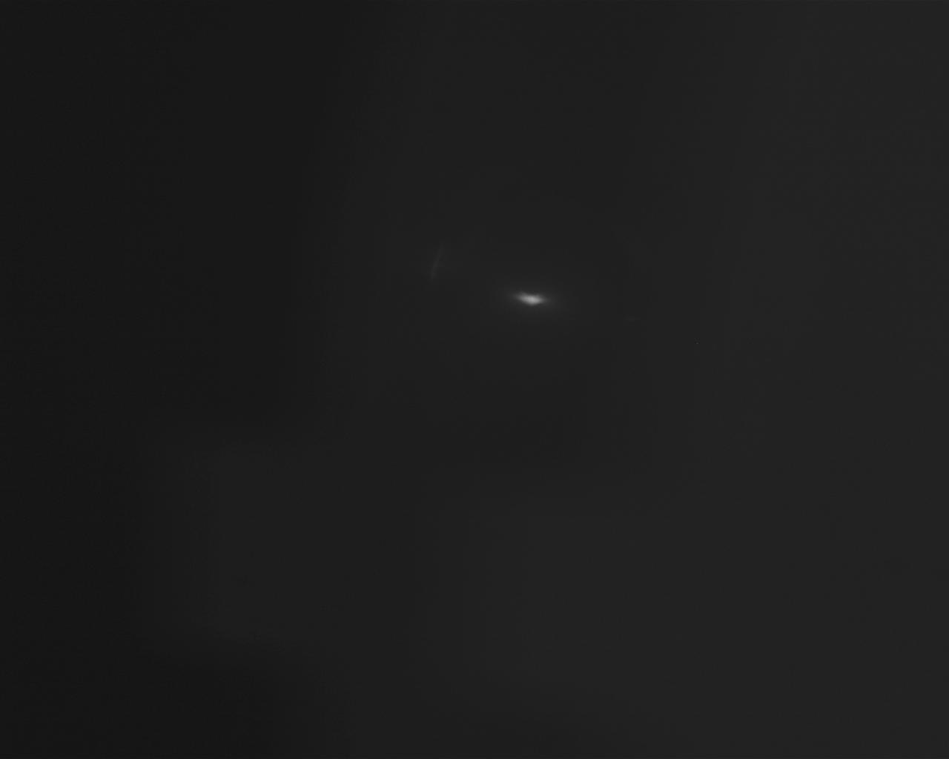

The derived formula gave a focal length of 27.4mm, again about half that is assumed. Also again, a closer answer is obtained by neglecting the factor of 0.5168, giving 52.9mm, still fairly close to the expected 50mm

One more of these pictures, here with the 75mm focal length lens, image 10cm behind the lens:

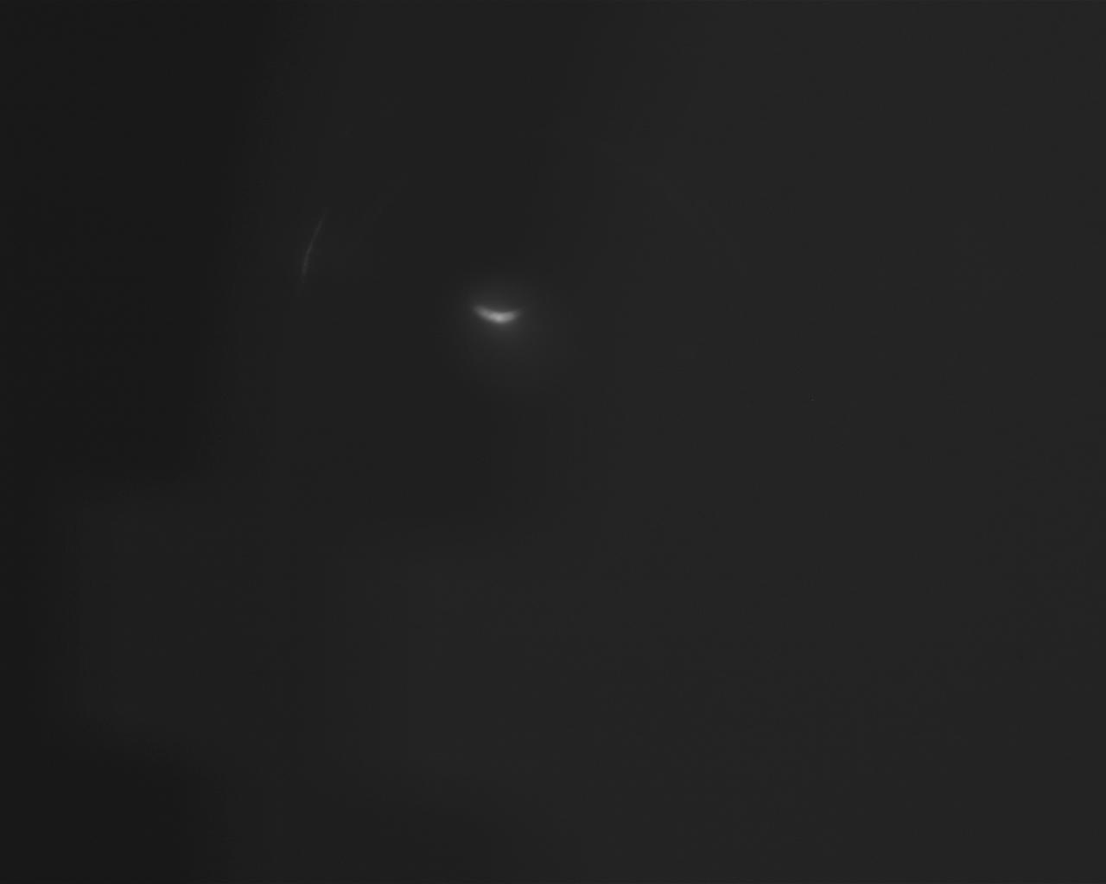

The formula for focal length gave 41.7mm, again around half the expected focal length. Neglecting the 0.5168 factor this time gives 80.7mm, which is a more acceptable measurement, although noticeably inaccurate itself.

The condenser train has to concentrate light onto an object so that said object can be imaged by optical instruments on the other side of the microscope. It requires the use of an aperture stop and a field stop, in addition to two lenses, one that reigns in diverging light so the second can focus the light as necessary. The distance between the two lenses had to be small, since a larger distances means less light is focused on the center lens. The condenser train was built with two 75mm focal length lenses, with the first lens 75mm behind the light source, and the distance between the two lenses and between the last lens and the camera was set to around 75mm, to try and keep 1:1 magnification. The second lens was moved from this point to try and focus the camera’s image. Once the image was focused, apertures were placed around the center of the two last distances for focusing purposes. The final design looked like this:



And the CCD camera showed this image:

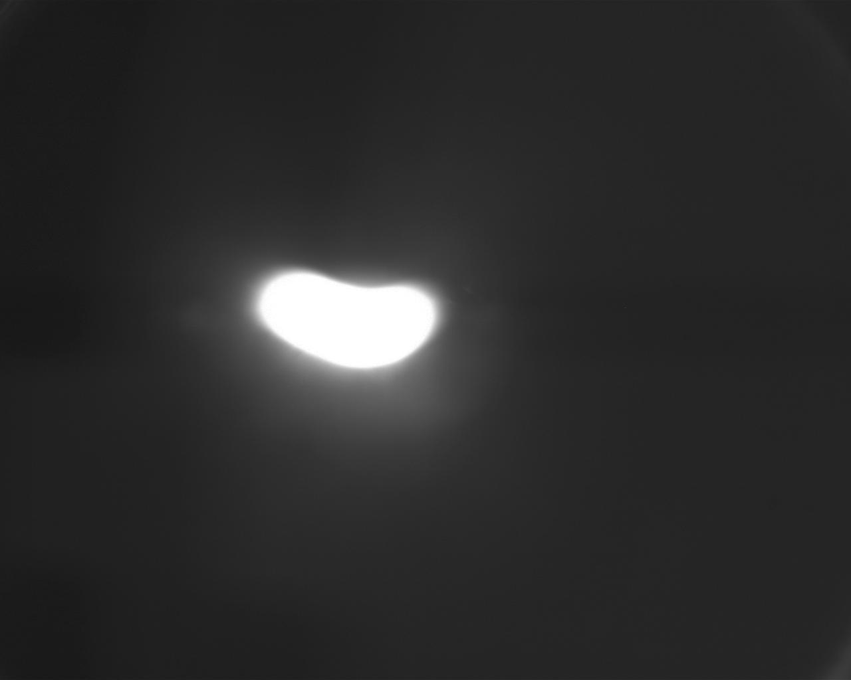

The object was then moved significantly to the right in the final microscope design, 15.0 cm to the right of the final iris rather than the 8.0cm it sits at in the design. The irises limit what light can and can’t get to the object. If one of them is partially closed, the second can’t affect the image until it limits more of the considered light beam than the other iris.

The imager train is supposed to image an object so that the CCD camera can image it properly. The design work for this portion is included in the PDF attachment with the submission.

However, this work uses formulae assuming imaging using the human eye, which is an incorrect assumption. The microscope, as described, resulted in this image of the graticule micrometer:

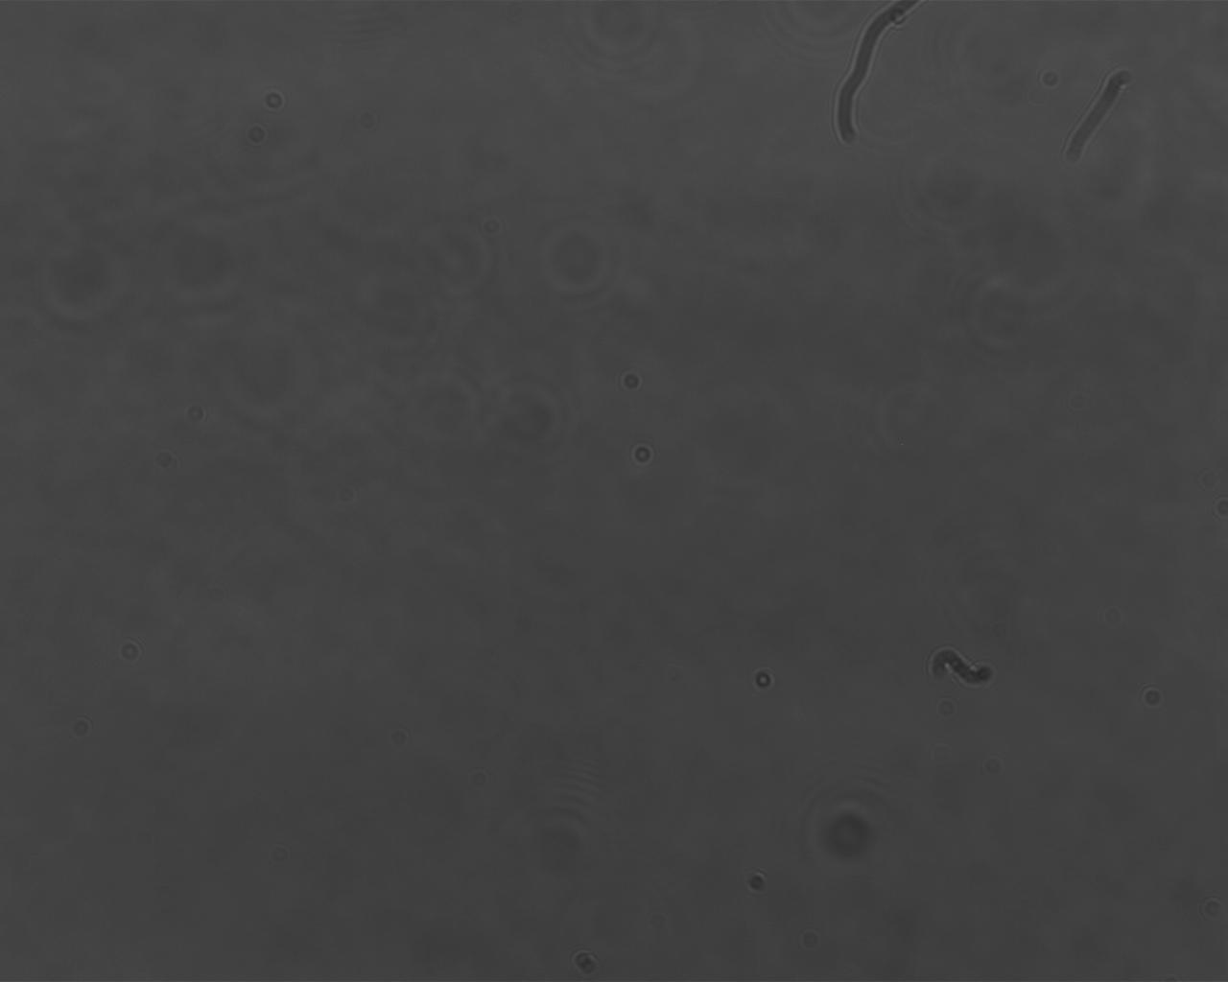

This system was a ways off from being useable, seen as it can’t image anything useful.

This design was still used as a sort of starting idea for the actual designed microscope. The 35mm lens in the design was still used as the first lens in the train, and the CCD camera was used to try and find a suitable position for the lens to properly focus the image, the graticule micrometer in this case. The lens was placed 5cm behind the object, and the image of the micrometer scale was formed 10cm farther back, leaving magnification of 2x. The image could be seen on a piece of paper placed at the image distance, just barely, given the miniscule magnification for such a small scale.

A second lens was added after the first, put at the distance suggested in the design and then adjusted to focus an image. The second lens, the 25.4mm focal length lens, was eventually left 13.0cm behind the first lens. Observing by eye, the scale on the micrometer observing through this portion of the imaging train was clearly visible, although only a portion of the scale was visible at any given time. Since the image was viewed with a human eye, the magnification displayed to said eye would follow the magnification formula used in the work for the failed system: -T\*25/(the focal lengths). The magnification is thus (-6.96x25/(2.54x3.5)) = 19.6x (inverted)

Two more lenses, a 30mm focal length lens and a 50mm focal length lens, in that order, were added to the imaging train at the distances suggested by the design, and were adjusted to find a clear image of the micrometer scale. They were adjusted a second time to try and find a better magnification. In the end, the following design was used:

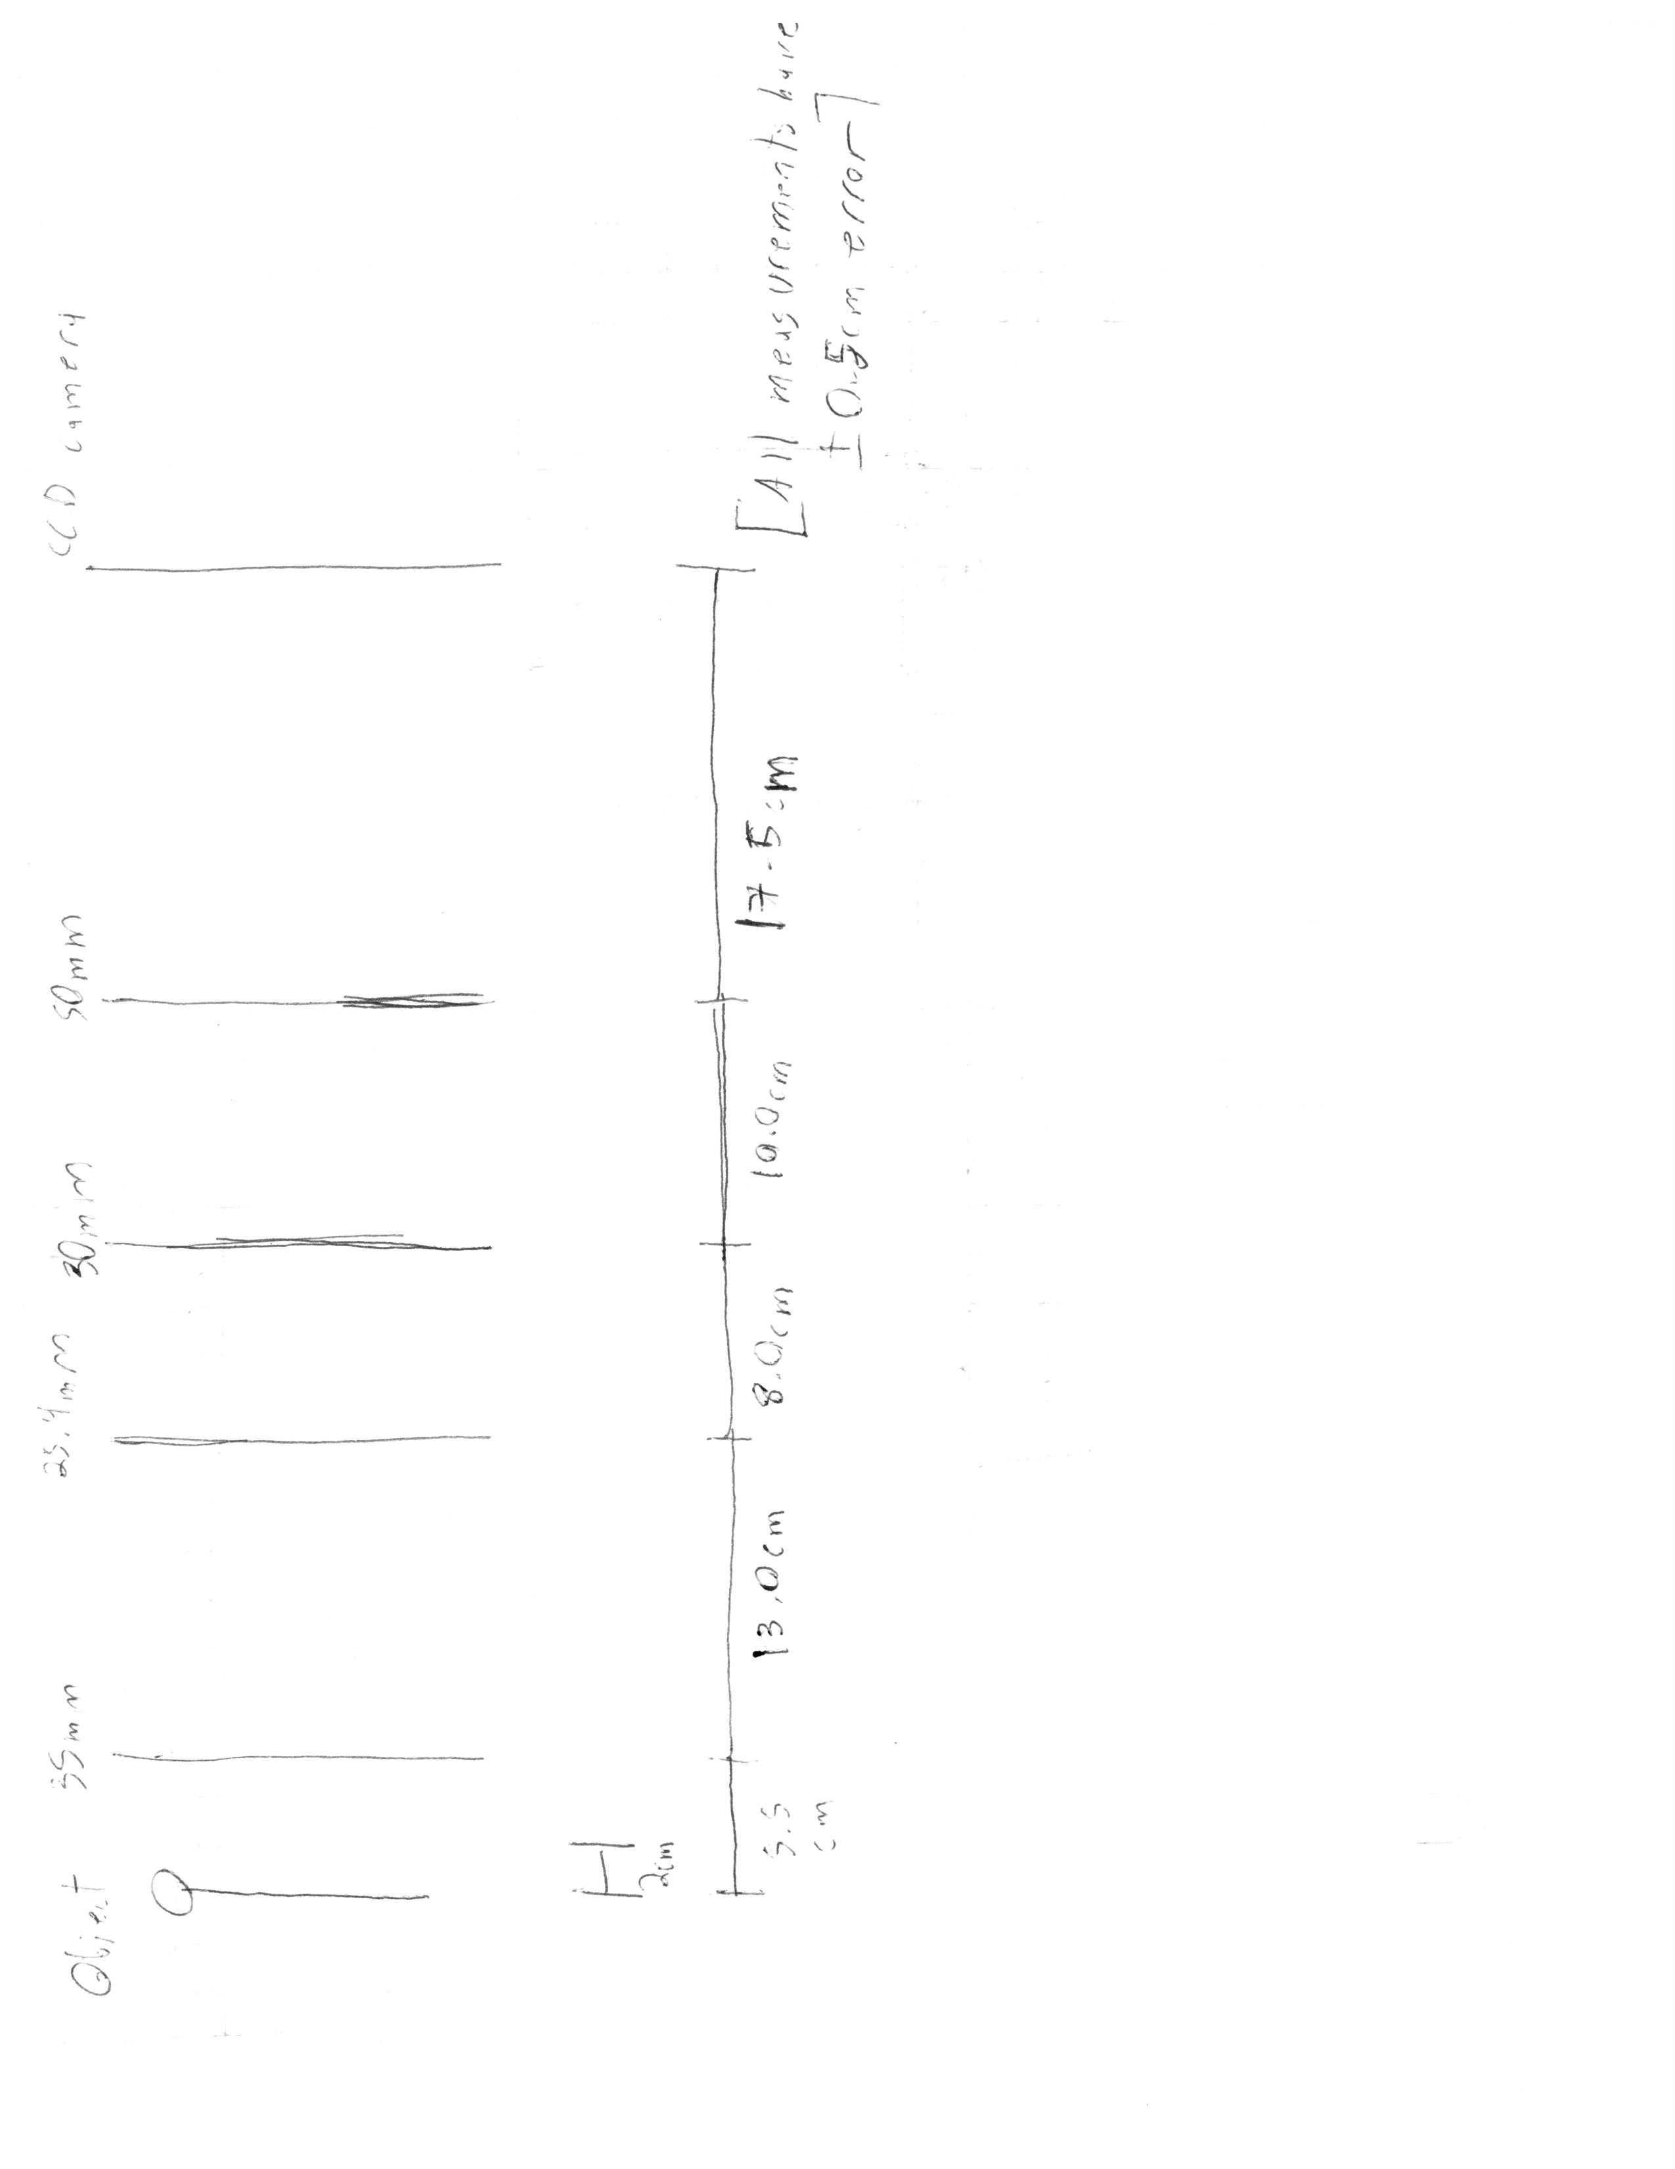

And the image of the micrometer was as follows:

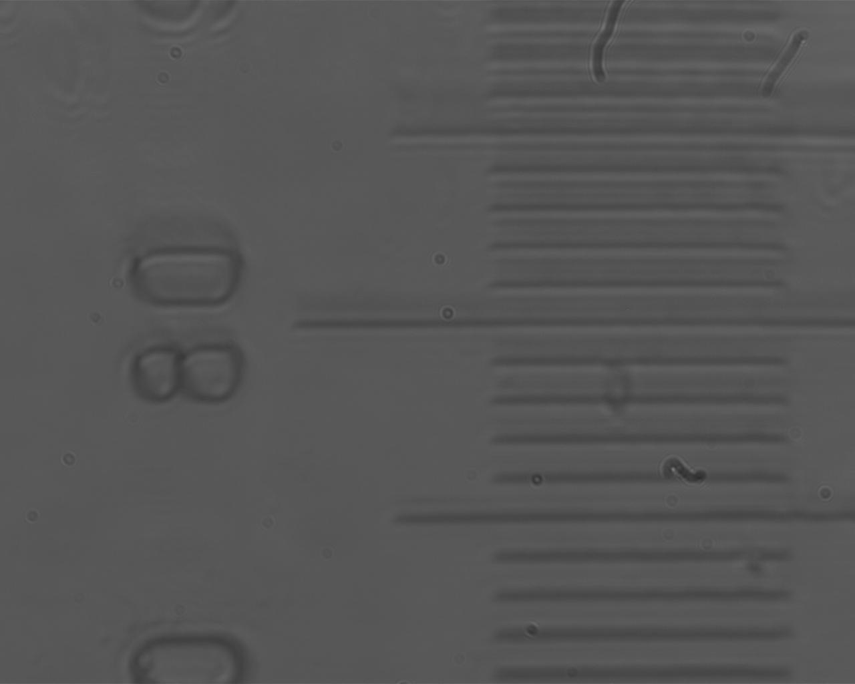

The image can be well discerned while still being admittedly blurry. The distance between two micrometer readings was 64.1 pixels. The Thor Labs website states that one pixel has a length of 5.2μm. The scale was supposed to be 5mm long, and was in 100 divisions, so one division on the micrometer was 50μm, or 9.615 pixels. (50/5.2) The magnification of this microscope was thus 6.67x, about six times less than the required minimum magnification of 40x. With the length between the first two lenses set at 13.5cm, and the two focal lengths of the lenses being 3.5cm and 2.54cm, the tube length was 6.96cm, also below specification by around 94mm.

The following were images of biological slides taken with the microscope as described above:

A hydra:

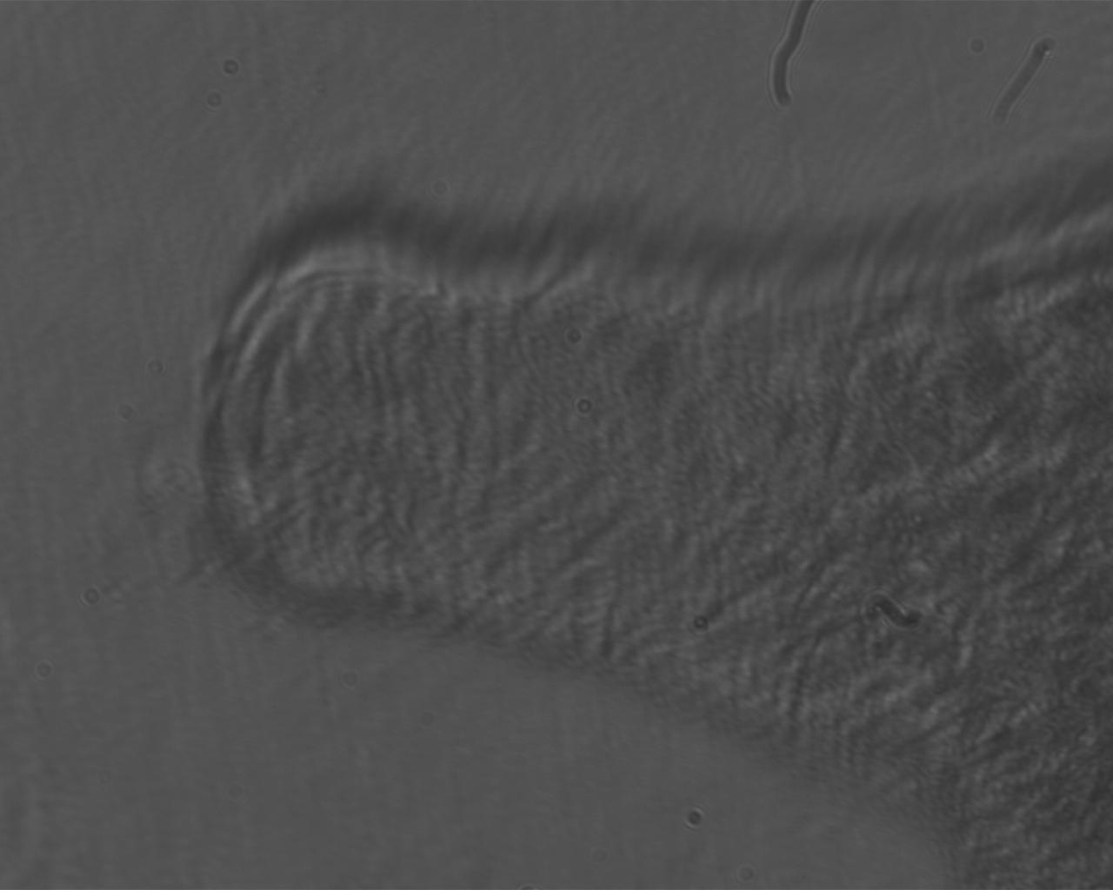

A small intestine sample:

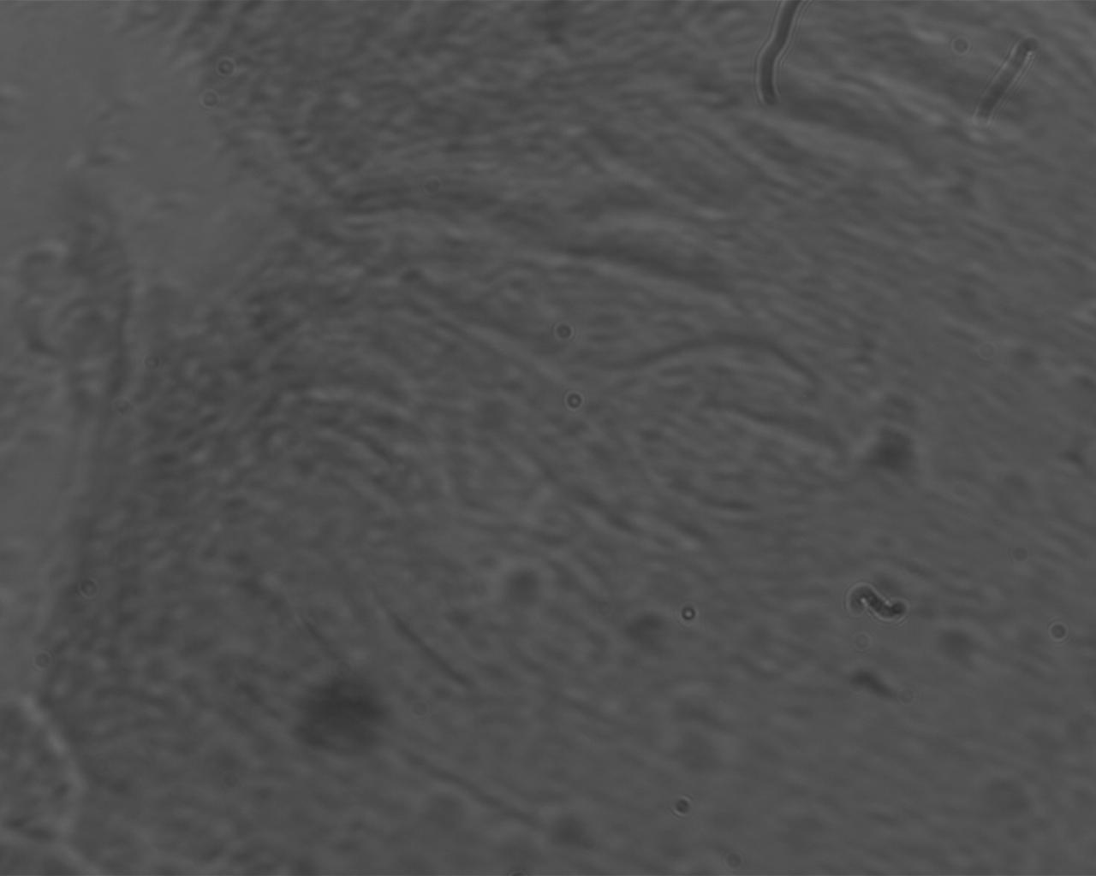

A pine leaf sample:

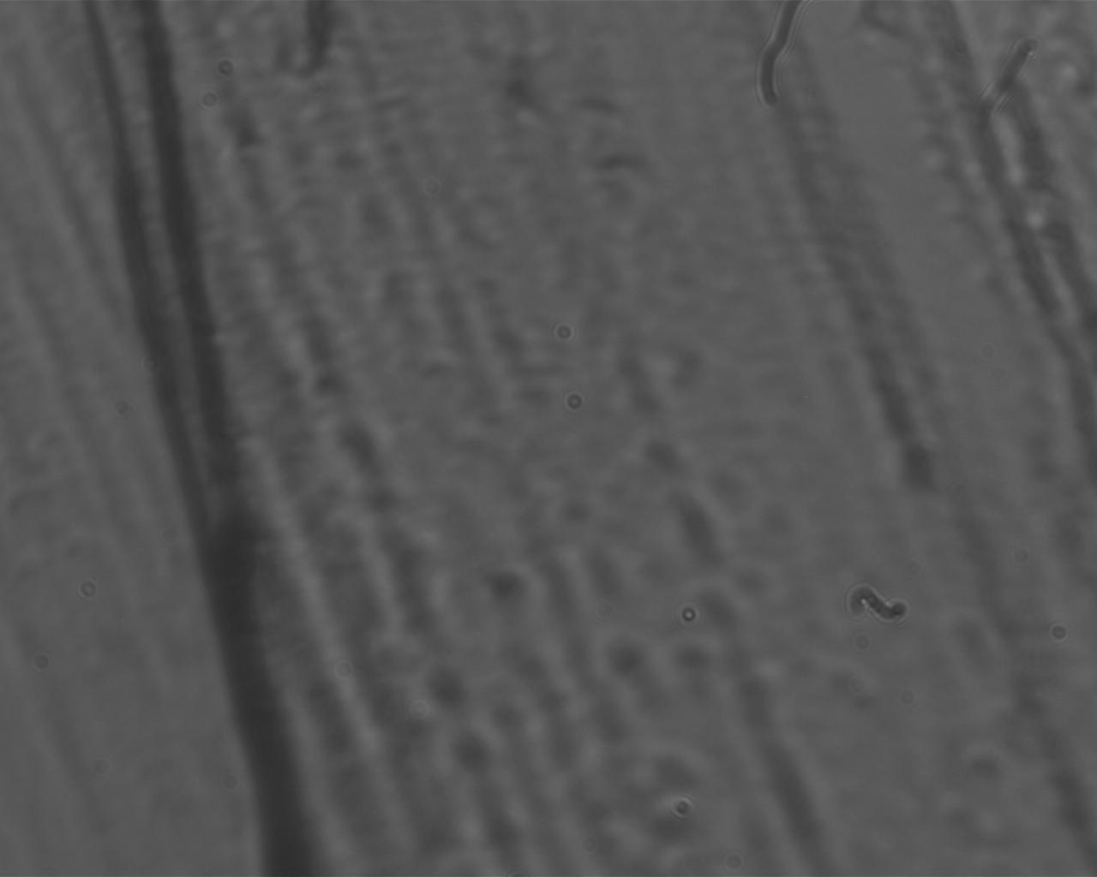

The apertures in the condenser train had very little effect on the detail viewed in the image. It caused a little change, but it’s likely that it would have demonstrated more change if there was more magnification.

The following was an image taken of the pinhole:

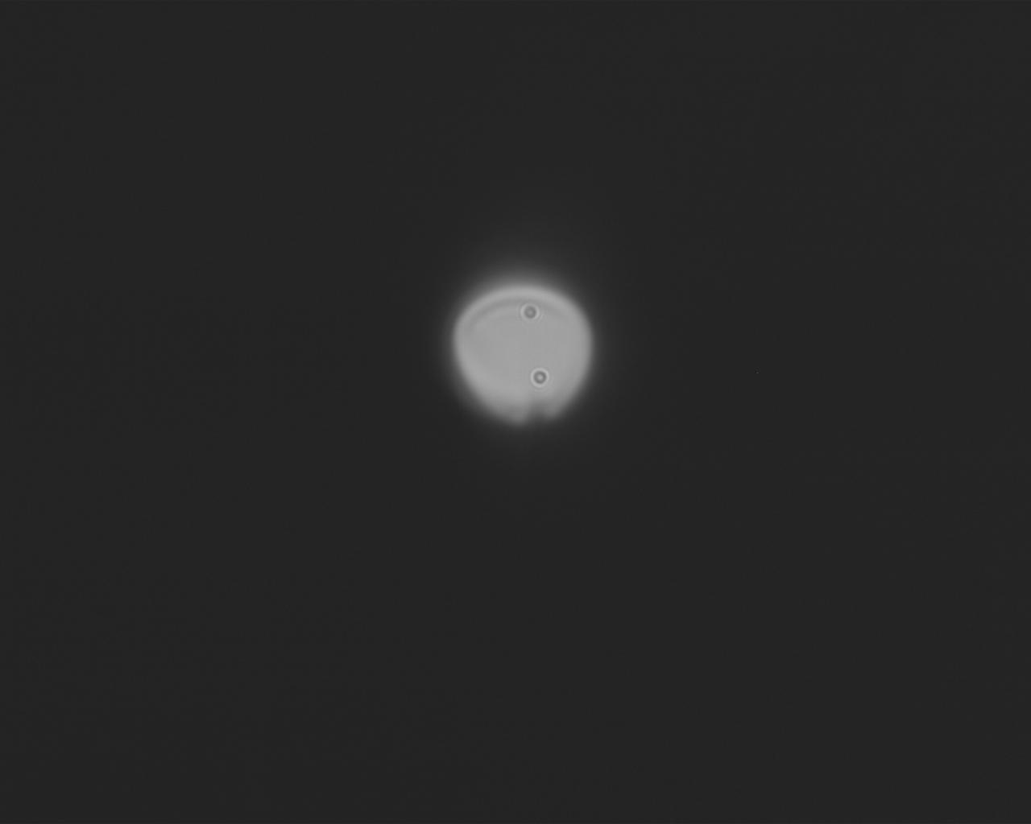

The image seems to have a little diffraction, observing the dark line by the top of the circle, a local minimum for the light. The line isn’t present at the bottom, but the image is subject to coma aberration, which could mask over the minimum on the bottom of the photograph. Empty magnification could also be a factor, where the resolution of an image suffers due to too much magnification, but due to the low magnification of the design this is doubtful. The measured diameter of the pinhole was 147.11 pixels, which results in a measurement of 147.11/(20/3)x5.2=114.75μm, which is off by around 24%. The measurement is of a somewhat similar magnitude to the actual size of the pinhole, but the error is very significant. The

The imager train has fairly decent tolerance for one misaligned lens, still giving a decent image for misalignment by noteworthy angles or heights, though the position of the image on the screen would change with the misalignment as one might expect. (Up and down as one lens is moved, and so forth) System tolerances for further misalignment of lenses after the first one decreases significantly as more misalignment from individual lenses is introduced. This is an image of light after the alignment of two lenses is altered:

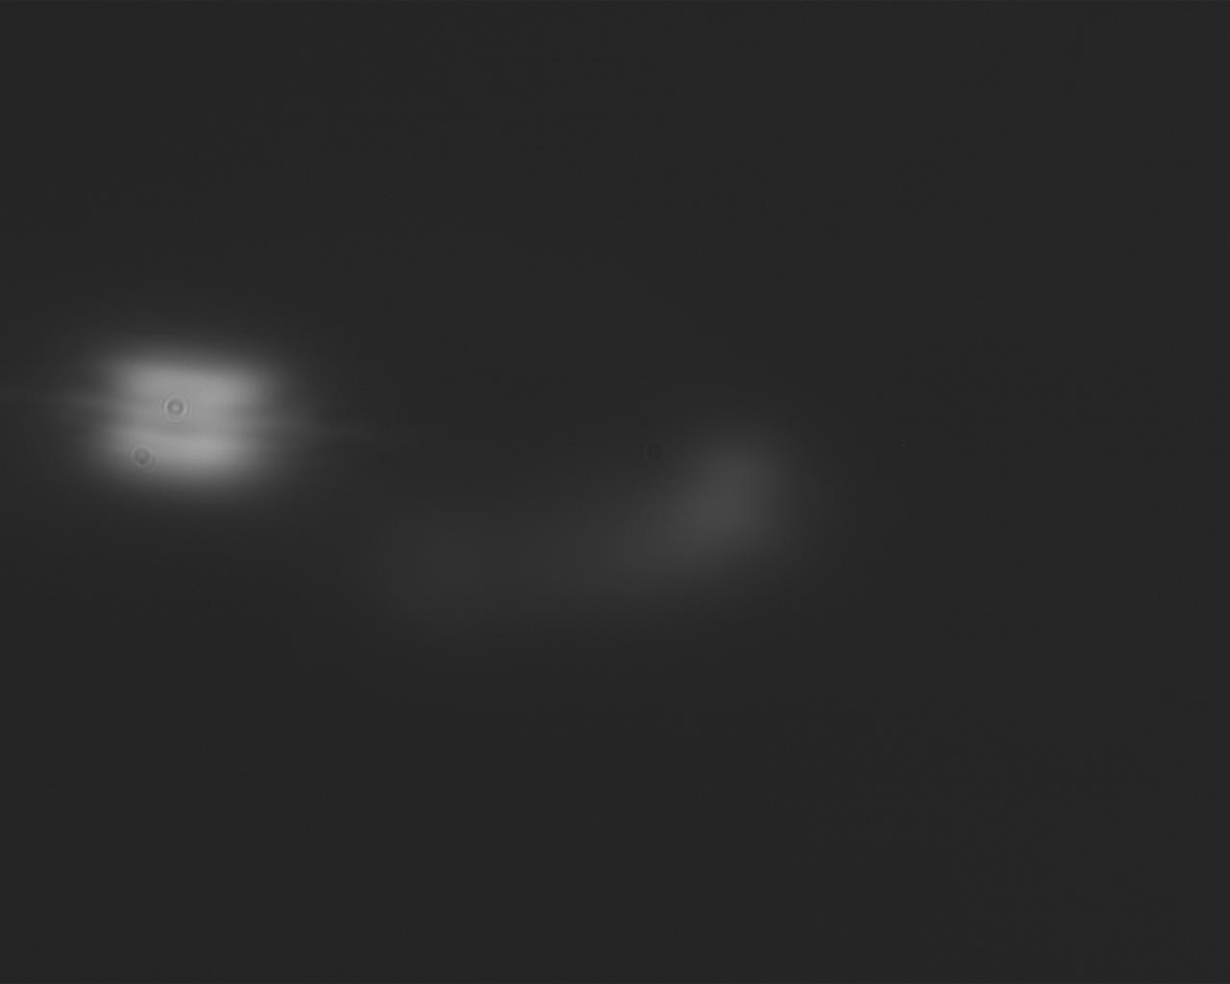

The light has been blurred and skewed, so badly that traces of light are appearing far away from where the central light is being imaged.